Director, SO
Minerals Business Centre, Minerals and Northern Compliance, Environmental Services and Regulation
 | Role type  Permanent/Flexible |  | Closing date  Thursday, 14 May 2026
 | Salary  annual $166,623 - $174,339  fortnightly $6,386.60 - $6,682.40  plus 12.75% super contributions |  | Contact  Filiz Tansley, Director (Reef Compliance), email at : filiz.tansley@detsi.qld.gov.au  Phone : 0436 621 418
 | Location  Cairns 5B Sheridan Street |  | Job ad reference  QLD/687703/26
 | Working relationships  Reports to: Executive Director, SES  Direct reports: 6 / Team size: 42 |  | For more information  Visit Working with us

Purpose
Directors play a key leadership role in the department, responsible for guiding high-performing teams to deliver critical programs and services that support environmental protection, biodiversity conservation, heritage preservation, and corporate service delivery.
As senior managers, Directors are accountable for achieving strategic outcomes, with a strong focus on operational excellence, the successful delivery of work programs, and the continuous improvement of services. They lead the planning, coordination and implementation of key initiatives, ensuring that team efforts are aligned with government priorities and community expectations.
Directors are expected to provide leadership across a range of areas, which may include:
- Program and service delivery
- Policy development and implementation
- Legislative reform and regulatory review
- Licensing, approvals, and compliance services
- Delivery of environmental, biodiversity and heritage programs
- Corporate and business services
To achieve these outcomes, Directors must foster effective working relationships with a broad range of internal and external stakeholders and service users, including:
- Peak bodies, industry and community groups
- Policy and regulatory reform agencies
- Recipients and users of departmental services
- Local, State and Federal Government entities
- Research institutions, universities and technical experts
- The Minister and staff of the Minister’s Office
- Aboriginal and Torres Strait Islander Traditional Owner groups
- The general public
The role
As the Director, you will:
- Provide high-level specialist policy and/or operational advice and direction to Executive Director and senior management teams within the region on a broad range of issues and initiatives.
- Contribute to the leadership and management of the department by representing senior management on significant state-wide forums, inter-and intra-government groups and forums.
- Develop and maintain highly effective collaborative relationships with:
- Internal stakeholders (including other government agencies) to ensure strategies are aligned to the departments and the broader government’s needs.
- External stakeholders with a view of keeping abreast of best practice and developing strategic alliances for the delivery of effective and efficient services, strategies and programs.
- Provide leadership in identifying and facilitating the development of innovative and proactive strategies to build the capacity of the business unit and/or region in effectively delivering its services, strategies and programs.
- Ensure appropriate workplace strategies are in place and opportunities for improvement and innovation are recognised and effectively incorporate into business processes.
- Ensure the provision of effective, consistent and timely performance metrics and reporting to assist strategic decisions and direction setting.
- Prepare high-level briefing material and reports for the Environmental Services and Regulation, Senior Management Team on complex issues and proposals.
- Lead and monitor significant, diverse and complex projects ensuring on-time and high-quality outcomes
- Promote a safe, respectful and inclusive workplace that is free from bullying, discrimination and harassment.
What we are looking for
We’re looking for the best-suited person for the role. If you are eligible, we will consider your skills, experience, qualifications and personal qualities relevant to the role. We may also consider your past work, your future contribution to our team and department and your commitment and contribution to equity, diversity, respect and inclusion.
What you need for this role  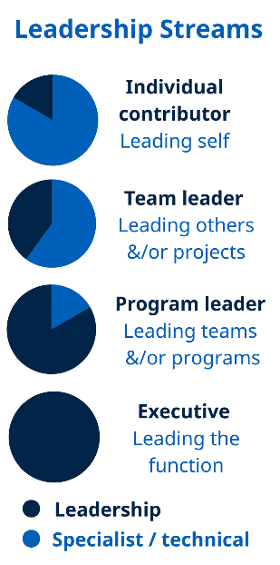 | Role model Program Leader leadership behaviours as outlined in the Leadership competencies for Queensland.  - Proven experience to lead and drive business performance and reform in a regulatory environment.  - Proven ability to motivate and engage staff, and lead through change, for the strategic delivery of environmental management services, programs and projects.  - A well-developed understanding of contemporary environmental and regulatory development trends, drivers and approaches  - Strong analytical and problem-solving capability, and the agility and resilience to adapt to a rapidly changing context.  - Superior stakeholder management to pursue the Environmental Services and Regulation division’s objectives through communicating with influence in a contested environment.  - Demonstrate how you can support our commitment to workplace safety, equity, diversity, respect and inclusion.
Eligibility | You will need the legal right to work in Australia.  Licences  Whilst not mandatory requirement of the role, it is desirable to hold a current unrestricted driver licence.
Additional information | The successful applicant will be subject to pre-employment checksincluding disciplinary disclosure. Once employed, additional requirementsmay apply, such as probationary period, conflict of interest declarations, and lobbyist registration.
Travel | This position may require travel to other locations from time to time, including overnight stays.
How to apply
Everyone is welcome to apply. We offer priority consideration to applicants ho identify as an Aboriginal or Torres Strait Islander and have what you need for this role. Priority consideration applicants will be invited to participate in the next selection activity.
Please let us know what we can do to help you participate in the recruitment process and ensure your needs for cultural safety or workplace adjustments are considered. For more information on how-to-apply, including options for adjustments, visit Working with us.
To apply for this role, please provide us information about:
- your skills, experience, qualifications and personal qualities and how they align with the requirements in the What we are looking for section; and
- why you are the best-suited person for this role.
- You can provide these in a succinct resume (4 pages) and short statement (2 pages).
- If your application is progressed, you will need to provide evidence of your Eligibility.
Additional selection requirements
If you are applying under the following category you are required to provide additional documentation.
Aboriginal and/or Torres Strait Islander priority consideration
- To enable the selection panel to confirm that you are eligible for priority consideration, the panel requires: documentary evidence attesting to your Aboriginal or Torres Strait Islander descent. Full details and a Statutory Declaration template are available in the Evidence of Attribute - Aboriginal and/or Torres Strait Islander Identified Roles Guideline.
Submitting your application
Applications will be accepted through the Smart Jobs and Careers website www.smartjobs.qld.gov.au. If you are unable to apply online please contact 13 QGOV (13 74 68) or visit How to apply | Department of the Environment, Tourism, Science and Innovation (DETSI), Queensland.
Hand-delivered applications are not accepted.

